How to Appeal AIM Denials - Maine

WHEN to appeal: When AIM denies additional visits but more PT/OT visits are medically necessary AND the patient still has covered benefits available to use. (If the patient’s PT/OT benefits have been exhausted, then offer continued visits as private pay services.)

Example: AIM pre-authorized 4 visits initially, then 2 more visits on your 2nd pre-auth request. After providing all 6 approved visits, the patient still needs more. The patient has 20 covered visits per year and has only used 6. You are providing manual therapy that the patient cannot perform on him/herself at home. You are also doing therapeutic exercises with the patient that requires your hands-on expertise to ensure the patient is using appropriate recruitment patterns and/or the patient still requires exercises to be progressed to regain maximum functional improvement. (The patient is NOT just doing their home exercise program in your office.)

Example: AIM cuts a post-op patient’s visits off arbitrarily before the patient has progressed through the entire protocol.

1. WHO to appeal to:
- Do NOT ask AIM for a peer-to-peer review or a reconsideration unless you want to waste your time. A provider appeal or reconsideration is NOT the same as an official patient appeal. Patient appeals must be handled in accordance with state and federal laws under the Affordable Care Act (“ACA” or “Obamacare”). You want to appeal under the ACA rules for the best result. Your goal is to get escalate your appeal to the Independent External Review level (which will be the 2nd or 3rd appeal level, depending on the health plan) as quickly as possible for the best efficiency because the 1st level of internal appeal (and 2nd, if there is one) will likely rubber-stamp AIM’s decision without any additional consideration being given. Therefore, don’t waste a lot of time on your internal appeal efforts.
- Your patient will need to participate in the appeal process. If your patient does not want to participate, then s/he probably doesn’t care if s/he gets more therapy so don’t waste your time!
- You need to appeal to ANTHEM directly. AIM is NOT authorized to make official appeal decisions. How do you do that?

  - Each Anthem health plan, especially those that are self-insured, may have a different appeal fax number and address to send appeal requests to. You need to make sure you send your request to the proper place for it to be processed efficiently. That information is in your patient’s health plan document. Specifically, the “Summary Plan Description” or “Certificate of Insurance or something similar. The document will be 70-100+ pages. It will be available on the Anthem website when the patient logs into the site as a subscribe. Have the patient download and email you the PDF. Alternatively, you can have the patient log-in at your office so you can help them navigate to the right document.
  - For Anthem Medicare Advantage Plans, federal Medicare rules apply to the appeals process. Obtain the health plan document to determine the procedure. The rest of this procedure will cover commercial claims only.

Go to www.anthem.com

Have the patient log-in with their UserName and Password.

After logging in, click on the “My Plan” Drop-down menu.

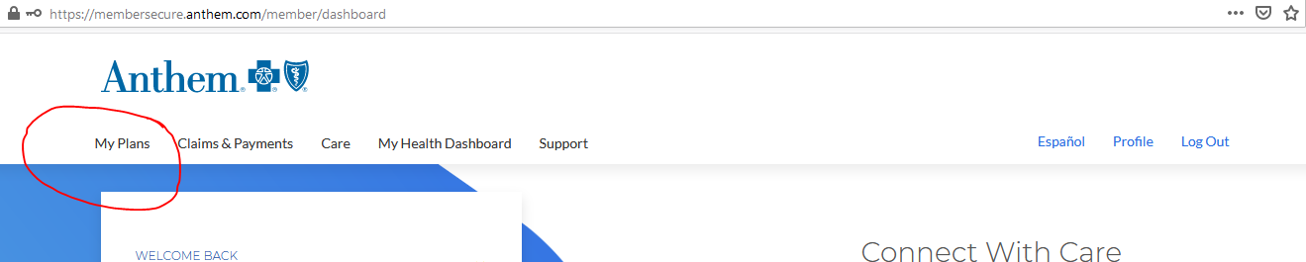

On the Drop-down menu (not shown), click on “Medical” and summary information about the plan will be displayed.

Scroll all the way to the bottom of that page until you get to a tab labeled “Plan Documents” and click on the link to the “Medical Certificate Booklet” (it may have a different but similar name in different plans) as shown in the screen shot below.

If the health plan is self-insured, it may call it the “Summary Plan Description.”
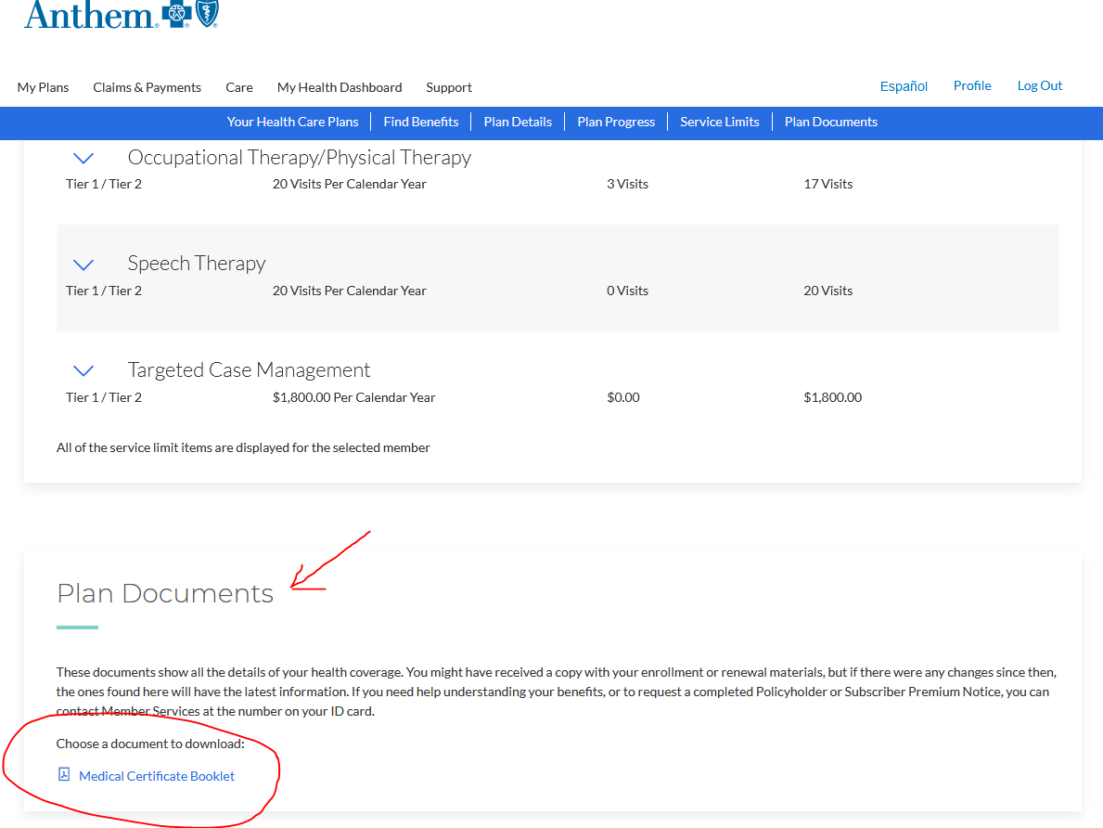

When you click on this link, it leads you to a document that looks something like this:

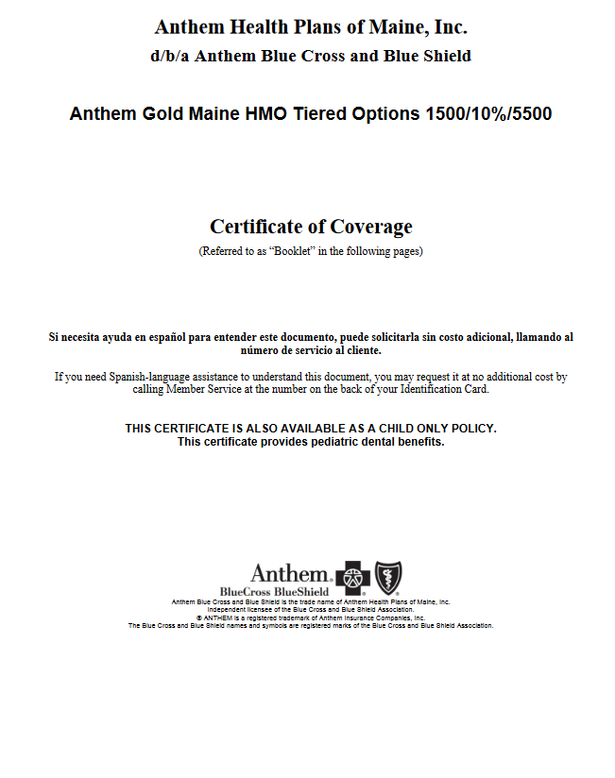
Or it may look like this – which is the Maine Health (self-insured) health plan:

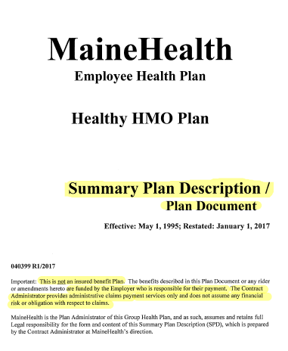

Each different Anthem Plan will have a unique document, so DON’T assume every Anthem Plan Medical Certificate Booklet is the same. It may be the same for all employees who have the health plan from the same employer unless the employer offers more than one health plan to its employees.

The laws governing appeals are slightly different depending on whether the health plan is self-insured or fully insured, so you need to figure this out at the outset. As previously stated, Medicare Advantage Plans are governed by Medicare appeals rules. Whatever the plan, the health plan document we are directing you to find will have the appeals procedures outlined for the patient in detail. Those are the procedures your patient should follow (with your help).

2. HOW to appeal – 1st level of review.
- Now that you found the health plan document, navigate to the appeals procedure page. There should be an address and a fax number for requesting an appeal. I recommend you request your appeal in writing for purposes of creating a paper trail.
- Don’t waste a lot of time on this internal appeal because it will likely fail.
- Use the sample written appeal request letter #1

3. How long should 1st level appeal decision take? You should receive it within 24 hours or the next working day since it is a concurrent care claim. If Anthem does not respond within that time frame, federal law says you get to jump to the next level of review without waiting for the answer. For most plans, the next level will be the independent external review. Larger health plans as allowed to require 2 levels of internal review before jumping to the independent external review, but most do not. The health plan document will say whether a 2nd level of internal appeal is mandatory. Look for language that explicitly says that level is mandatory vs. voluntary or optional. Do not file any requests for optional internal appeals!
4. HOW/WHEN to request the Independent External Organization (IRO) Review.
- Be ready to file your request for an IRO review as soon as you get the answer to the internal appeal.
- If the health plan is fully insured, your request for appeal will go to Maine’s Bureau of Insurance. If the health plan is self-insured, you need to refer to the health plan document to see who you need to send the appeal request to. It will likely be Anthem, but Anthem does not do the actual appeal – they only schedule the appeal with the IRO. Note – some self-insured health plans, like the Maine State Employee Health Plan, are governed by state laws, so your appeal request will go to the Bureau even though that plan is self-insured.

Procedure for Requesting an IRO appeal with Maine’s Bureau of Insurance:

- Patient (with your help) needs to fill out the “External Review Application Form” on the Bureau’s website. The form can be accessed at https://www.maine.gov/pfr/insurance/consumer/individuals_families/health/complaints_appeals_externalreviews/pdf/external_review_application_form.pdf
- Notice that Section II on the form allows the patient to appoint an Authorized Representative. This is where you will put the provider’s information if you want to be the Authorized Rep.
- Attach a letter from the treating PT. (See Section V – what to attach). This is where you describe why you disagree with AIM/Anthem’s decision. You need to get in all the facts but keep it simple so it doesn’t take much time. You are not arguing your case here, so you only have to get in enough facts to convince the Bureau you are entitled to a review.
  - Items they ask you to attach. You won’t likely have the denial letter yet to attach, so just state that the patient was informed by phone that the internal appeal resulted in a denial.
  - Attach a brief letter from the PT which covers the following talking points:
    - Statement of care provided to date. Patient was seen X times for physical therapy for [what] diagnosis.
    - Information about denial. Upon the expiration of these pre-authorized visits, a request for more visits was denied by AIM, the utilization review agent for Anthem. Anthem rubber-stamped this denial in the 1st level appeal.
    - Statement about qualification for concurrent/expedited appeal. The patient has not completed his/her treatment plan, which was originally for ___ visits over the course of ___ weeks. Therefore. this qualifies as a concurrent care claim and needs to be expedited. Additionally, the patient will not regain maximum function if care is delayed.
    - Statement of Rebuttal to AIM/Anthem Denial.
      - Not making progress. AIM is notorious for denying visits because the patient is not making progress when actually s/he is. Simply state that. Keep in mind though, AIM made their decision based on the information you submitted, so it AIM did not ask for additional records when you requested more visits, their decision might be only on the questionnaire scores you submitted. If those scores do not show improvement, you will need to briefly report what other tests and measures show improvement. For instance, simply state,

“AIM did not ask for our progress notes. If they had, they would have seen that the patient made improvements in ROM and/or strength.”
      - Further treatment is not necessary because you can continue to make gains on a home exercise program. See medical necessity statements below.

    - Statement of Medical Necessity. Don’t make this harder than it has to be! Sample statements could be:
      - “The patient was receiving hands-on manual therapy for joint and/or soft tissue mobilization that the patient cannot do on their own. S/he will not be able to regain maximum function and/or have a reduction/alleviation of pain without further manual therapy treatment.”
      - “The patient has not progressed through the exercise protocol required to regain maximum function. Further instruction is needed when the patient has made adequate physiological gains and is ready to progress to the next level.”
      - “The post-op protocol requires ___ weeks of physical therapy. The patient has not progressed through the protocol yet and therefore still needs PT.”
    - State how many more visits you anticipate needing. Be honest. If you are successful on this appeal, you will get all the visits you want approved. That said, do not ask for more than what is medically reasonable. If you look like you are over-utilizing PT, you will lose credibility with the reviewer.
      - If you use FOTO, gather the FOTO data that estimates the number of visits needed based on the diagnosis and the other data you would have entered on the patient on the first visit. This can be very powerful!

5. Prepare for the Review. The review will be a short phone call. It is very informal. The reviewer will likely be a physician.
- Scheduling. The Bureau will schedule your review with the IRO. On an expedited appeal, it should be schedule within a couple of days, but sometimes it is difficult to get the patient’s, PT’s and reviewer’s schedules to align.
- What to send in advance of the call. The reviewer will get records from Anthem in advance, but they won’t likely have all the PT progress notes. Remember, they only have what you sent to AIM and they may not even have that if they did not get it from AIM. As soon as the IRO is assigned, the patient should get a letter (by email or fax) stating how to submit additional information you want the reviewer to consider. If you were appointed as the Authorized Rep, you should receive this correspondence. You should submit the evaluation and all your progress notes to date. Don’t think you have to send research articles or anything else to support medical necessity, but you can if you wish to spend additional time on the case.
- PT participation. The treating PT should participate in this call to make a brief statement at the beginning about the patient’s course of treatment and why additional visits are required. The call will only take about 30 minutes, but you might want to block out an hour.
- What to expect on the call.
  - The reviewer should have looked at all the documentation you and Anthem submitted, including the adverse benefit determination letter, before the call. You/the patient will be permitted to make a statement about why you think additional PT is necessary. I recommend you briefly review the things in your PT record that show progress and medical necessity to draw the reviewer’s attention to the things that support your case but don’t bore him/her with a review of the entire case if s/he told you s/he already reviewed the records.
  - Anthem will not likely show up for the call. It simply isn’t worth their time. Therefore, you don’t have to be intimidated. If they do show up, they won’t likely know enough about the facts of the case to rebut your position.
  - You’ll probably get a clue about how the reviewer is leaning by the questions s/he asks you after your opening statement, but s/he probably won’t give you a definitive decision.
  - The written decision should come within 1-2 days after the review. Hopefully you will get all the visits you want approved. The decision is binding on Anthem, so you do NOT have to get pre-authorization for those visits from AIM for the remainder of the treatment – not until you exceed the visits the IRO deemed were necessary.

Sample Appeal Request Letter (to fax) – level 1 internal appeal

Insured’s/Participant’s name
Insured’s/Participant’s address
City, State, Zip
Policy Number

Date

Anthem BCBS
Attn: Appeals Department [or to whom the health plan document directs you to send]
Street address
City, State, Zip Code
Delivered via fax to: _________________

RE: Request for Expedited Appeal of a Concurrent Care Claim – denied physical therapy visits

To Whom it May Concern:

My name is _________________________. I have been receiving physical therapy at _____________(clinic name) for [diagnosis] pursuant to the referral of my [PCP or specialist], Dr. ________. So far I have had ___ visits of [manual therapy, therapeutic exercise, etc.] and was in the middle of my treatment plan when your utilization review agent, AIM, failed to authorize any additional visits on _____. My PT and my physician believe additional visits of skilled therapy are medically necessary and disagree with AIM’s decision. Therefore, I am entitled to an expedited review within the next 24 hours since this is a concurrent care claim and interruptions in my care could interfere with my ability to regain maximum function and/or result in my pain becoming unmanageable.
In order to have a full and fair review, I respectfully request a copy of the entire administrative file on my case, including the medical records or any other information that the adverse benefit determination was based on. If you need additional information for me to perfect my claim, you are required to tell me precisely what information you need and why it is necessary. Please forward these materials to me at [insert email or fax number where you want the documents sent].

Thank you,

_______________________________________
[patient’s name]

